Group 3 Term Project 4 ECEC 412

11/30/2017

**Addition Subtraction Test of FPU**

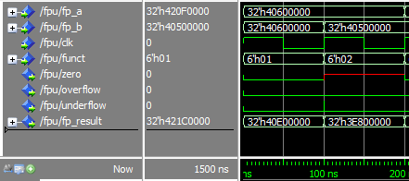

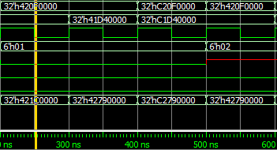

**NOTE: INPUT ERROR FROM 200 TO 300 ns DISREGARD THAT SIMULATION CYCLE**

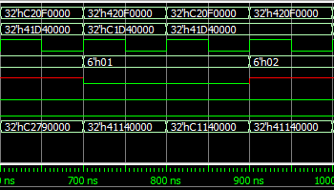

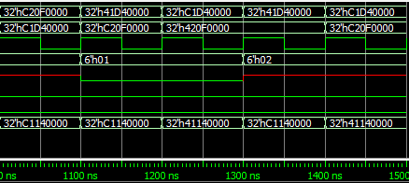

ADD/SUB:

3.5 + 3.5 = 7

0x40600000 + 0x40600000 = 0x40e00000

3.5 – 3.25 = 0.25

0x40600000 – 0x40500000 = 0x3e800000

35.75 + 26.5 = 62.25

0x420f0000 + 0x41d40000 = 0x42790000

(-35.75) + (-26.5) = -62.25

0xc20f0000 + 0xc1d40000 = 0xc2790000

35.75 – (-26.5) = 62.25

0x420f0000 - 0xc1d40000 = 0x42790000

(-35.75) - 26.5 = -62.25

0xc20f0000 - 0x41d40000 = 0xc2790000

35.75 + (-26.5) = 9.25

0x420f0000 + 0xc1d40000 = 0x41140000

-35.75 + 26.5 = -9.25

0xc20f0000 + 0x41d40000 = 0xc1140000

35.75 - 26.5 = 9.25

0x420f0000 - 0x41d40000 = 0x41140000

-35.75 – (-26.5) = -9.25

0xc20f0000 - 0xc1d40000 = 0xc1140000

26.5 + (-35.75) = -9.25

0x41d40000 + 0xc20f0000 = 0xc1140000

-26.5 + 35.75 = 9.25

0xc1d40000 + 0x420f0000 = 0x41140000

26.5 – 35.75 = -9.25

0x41d40000 - 0x420f0000 = 0xc1140000

-26.5 – (-35.75) = 9.25

0xc1d40000 - 0xc20f0000 = 0x41140000

**Multiplication Division Test of FPU**

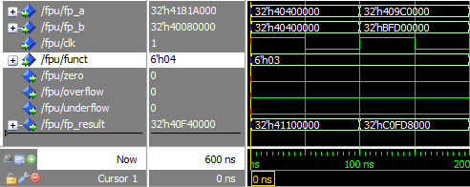

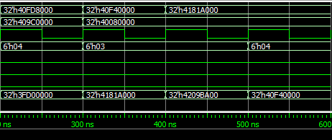

**NOTE: INCORRECT INPUTS FROM 400 TO 500 ns IGNORE RESULTS IN THAT CYCLE**

MULTI/DIV:

3.0 * 3.0 = 9

0x40400000 * 0x40400000 = 0x41100000

4.875 * -1.625 = -7.921875

0x409c0000 * 0xbfd00000 = 0xc0fd8000

7.921875 / 4.875 = 1.625

0x40fd8000 / 0x409c0000 = 0x3fd00000

7.625 * 2.125 = 16.203125

0x40f40000 * 0x40080000 = 0x4181a000

16.203125 / 2.125 = 7.625

0x4181a000 / 0x40080000 = 0x40f40000